This document is partly adapted from an edited version of Tony R. Kuphaldt's 'Lessons In Electric Circuits series of textbooks on the subjects of electricity and electronics (Copyright (C) 2000-2020,) which allow for free copying, distribution, and/or modification by the general public.

Foreword

I'm going to skip a lot of detail simply because i'm trying to fast forward you to the useful stuff.
I'm assuming you're not trying to build a transistor, design anything requiring difficult mathematics, design a complex circuit or even connect up anything affected by the more complex aspects of current/voltage/electrons.

I am writing this in case you want to do more than just randomly plug wires into modules, specifically logic, sequencing and switching modules.
I am also writing this for those who may want to make modifications to RYO modules or to build expanders to RYO modules with expansion headers or pads for adding expansion options.

As such there's a mixture of basic information on how logic works, electronic logic works, more complex components built of logic, and more complex components built of those components work.
This goes right up to near the level of how full blown computers work (not in extreme detail) so as to cover how the most complex RYO modules like the VC Sequencer work, both theoretically and practically.

This also might provide inspiration for some of the more adventurous wigglers of modular synths to build patches involving whole serge style patch programmable, complex, multiple module assemblies that have higher order functions similar to some of the computer parts or even simple computers described later in this document.

Contents and Why

- Transistors (only a little info) because RYO logic modules, the more complex RYO modules, and computers are built of or based on parts built of them.
- Logic Theory (and a little of the electronics - no math here) and because RYO's simplest modules are the logic modules and the concepts allow grasping of the more complex part of sequencers and computers.
- Combinational Logic because it explains specifically the operation and building of encoders/decoders, multiplexers and some other stuff used in RYO modules and computers.
- Sequential logic and multivibrators, as above because both go to explain how the stuff used in some RYO modules and computers work, specifically counters and shift registers.
- some types of DAC's and ADC's because they are used in the RYO VC Seq, some other parts of RYO sequencing, logic and switching modules and also in certain computing and audio applications.

Bipolar transistors

The simplest form of transistor to understand is the bipolar junction transistor. For our purposes, all you really need to be aware of (vaguely), is the following:

The three leads of a bipolar transistor are called the Emitter, Base, and Collector.

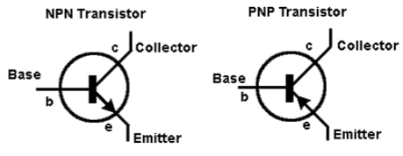

- Transistors function as current regulators by allowing a small current to control a larger current.

- The amount of current allowed between collector and emitter is primarily determined by the amount of current moving between base and emitter.

Note, currents go against the emitter arrow symbol.

- When a transistor has zero current through it, it is said to be in a state of cutoff (fully nonconducting).
- When a transistor has maximum current through it, it is said to be in a state of saturation (fully conducting).

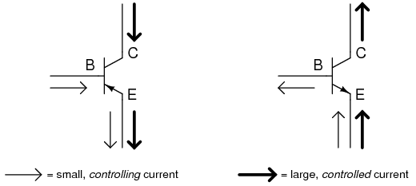

logic

In this circuit, the transistor is in a state of saturation by virtue of the applied input voltage (5 volts) through the two-position swi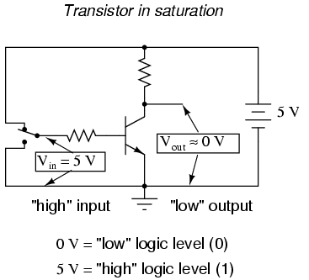

- the saturated transistor drops very little voltage between collector and emitter, resulting in an output voltage of (practically) 0 volts.

- If we were using this circuit to represent binary bits, we would say that the input signal is a binary "1" and that the output signal is a binary "0".

- Any voltage close to full supply voltage (measured in reference to ground, of course) is considered a "1" and a lack of voltage is considered a "0".

- Alternative terms for these voltage levels are high (same as a binary "1") and low (same as a binary "0").

- A general term for the representation of a binary bit by a circuit voltage is logic level.

- Moving the switch to the other position, applying a binary "0" to the input we receive a binary "1" at the output:

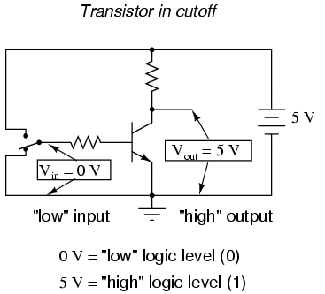

- What we've created here with a single transistor is a circuit generally known as a logic gate, or simply gate.

- The gate shown here with the single transistor is known as an inverter, or NOT gate, because it outputs the exact opposite digital signal as what is input.

- For convenience, gate circuits are generally represented by their own symbols rather than by their constituent transistors and resistors.

- The following is the symbol for an inverter:

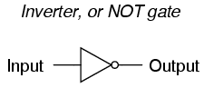

- One common way to express the particular function of a gate circuit is called a truth table.

- Truth tables show all combinations of input conditions in terms of logic level states (either "high" or "low," "1" or "0," for each input terminal of the gate), along with the corresponding output logic level, either "high" or "low."

- For the inverter, or NOT, circuit just illustrated, the truth table is very simple indeed:

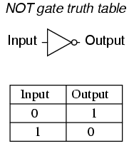

Other Gates

- Two inverter, or NOT, gates connected in "series" so as to invert, then re-invert, a binary bit perform the function of a buffer.

- Buffer gates merely serve the purpose of signal amplification: taking a "weak" signal source that isn't capable of sourcing or sinking much current, and boosting the current capacity of the signal so as to be able to drive a load.

- Buffer circuits are symbolized by a triangle symbol with no inverter "bubble.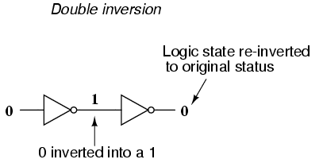

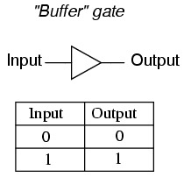

- Adding more input terminals to the circuit(s) gives more logic gate possibilities:

- With a single-input gate such as the inverter or buffer, there can only be two possible input states: either the input is "high" (1) or it is "low" (0).

- A two input gate has four possibilities (00, 01, 10, and 11).

The AND gate

- One of the easiest multiple-input gates to understand is the AND gate,

- The output of the AND gate will be "high" (1) if and only if all inputs (first input and the second input) are "high" (1).

- If any input(s) are "low" (0), the output is guaranteed to be in a "low" state as well.

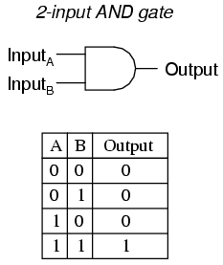

The NAND gate

- The NAND gate is a variation on the idea of the AND gate.

- The word "NAND" is a verbal contraction of the words NOT and AND.

- Essentially, a NAND gate behaves the same as an AND gate with a NOT (inverter) gate connected to the output terminal.

- To symbolize this output signal inversion the NAND gate symbol has a bubble on the output line.

- The truth table for a NAND gate is as one might expect, exactly opposite as that of an AND gate:

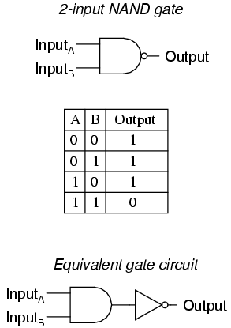

- As with AND gates, NAND gates are made with more than two inputs. In such cases, the same general principle applies:

- The output will be "low" (0) if and only if all inputs are "high" (1).

- If any input is "low" (0), the output will go "high" (1).

TTL

- Real inverter circuits contain more than one transistor to maximize voltage gain (so as to ensure that the final output transistor is either in full cutoff or full saturation), and other components designed to reduce the chance of accidental damage.

- Shown here is a schematic diagram for a real inverter circuit, complete with all necessary components for efficient and reliable operation:

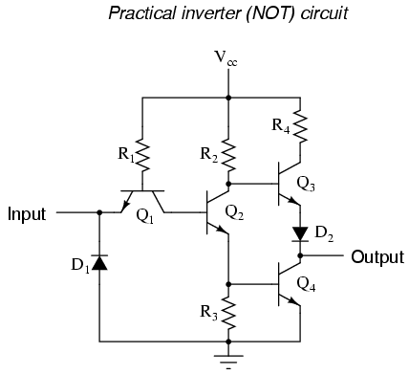

- Gate circuits constructed of resistors, diodes and bipolar transistors as illustrated in this section are called TTL.

- TTL is an acronym standing for Transistor-to-Transistor Logic.

- Suppose we altered our basic inverter circuit, adding a second input terminal just like the first:

(A simple transistor structure is inadequate to simulate the three junctions necessary in this network), so a different transistor (and symbol) is needed;

This transistor has one collector, one base, and two emitters like this: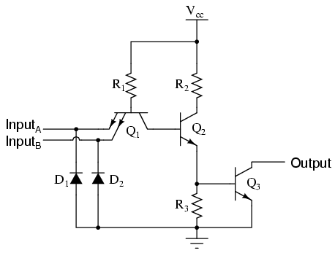

- The only difference to the simple inverter circuit is a second input terminal connected in the same way to the base of transistor Q2.

- We can say that each of the inputs will have the same effect on the output,

- i.e. if either of the inputs are grounded, transistor Q2 will be forced into a condition of cutoff, thus turning Q3 off and the output goes "high".

- In any case where there is a grounded ("low") input, the output is guaranteed to be "high".

- Conversely, the only time the output will ever go "low" is if transistor Q3turns on, which means transistor Q2 must be turned on (saturated).

- This means neither input can be diverting R1 current away from the base of Q2. The only condition that will satisfy this requirement is when both inputs are "high".

- Collecting and tabulating these results into a truth table, we see that the pattern matches that of the NAND gate:

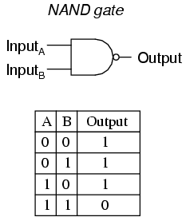

- In other words, a TTL NAND gate can be made by taking a TTL inverter circuit and adding another input.

- Consequently, An AND gate may be created by adding an inverter stage to the output of the NAND gate circuit.

OR Gates

- The OR gate is so-called because the output of this gate will be "high" (1) if any of the inputs (first input or the second input) are "high" (1).

- The output of an OR gate goes "low" (0) if and only if all inputs are "low" (0).

- Consequently the NOR gate is an OR gate with its output inverted, just like a NAND gate is an AND gate with an inverted output.

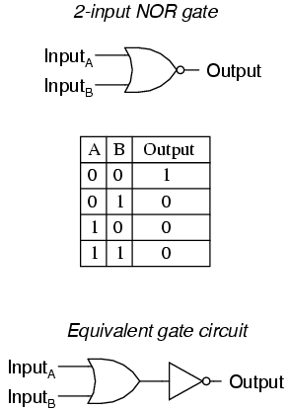

- Exclusive-OR gates output a "high" (1) logic level if the inputs are at different logic levels, either 0 and 1 or 1 and 0.

- Conversely, they output a "low" (0) logic level if the inputs are at the same logic levels.

- The Exclusive-OR (sometimes called XOR) gate has both a symbol and a truth table pattern that is unique:

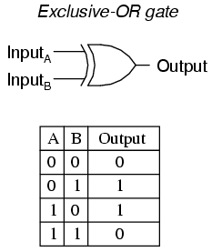

- The Exclusive-NOR gate, otherwise known as the XNOR gate is equivalent to an Exclusive-OR gate with an inverted output. T

- The truth table for this gate is exactly opposite as for the Exclusive-OR gate:

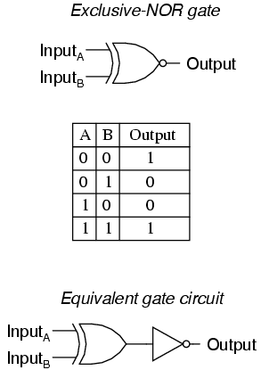

To sum up, the six most common and useful logic gates:

- An AND gate: output is "high" only if first input and second input are both "high"
- A NAND gate: output is not "high" if both the first input and the second input are "high"

- An OR gate: output is "high" if input A or input B are "high"
- A NOR gate: output is not "high" if either the first input or the second input are "high"

- An XOR gate: output is "high" if the input logic levels are different
- An XNOR gate: output is "high" if the input logic levels are the same

Combinational Logic

In mathematics a combination is an unordered set, which is a formal way to say that nobody cares which order the items came in.

With combinational logic, the circuit produces the same output regardless of the order the inputs are changed.

Combinational logic perform functions like arithmetic, logic, or conversion.
Each logic gate discussed previously is a combinational logic function.
Following, see how two NAND gates work if provided with inputs in different orders.
Beginning with both inputs being 0:

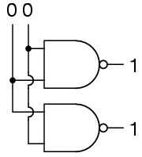

Then setting one input high:

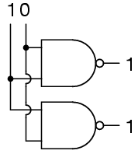

Then setting the other input high:

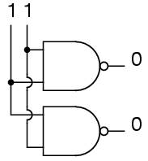

So NAND gates do not care about the order of the inputs, and the same is true of all the other gates covered up to this point (AND, XOR, OR, NOR, XNOR, and NOT).

A Half-Adder

(please note: the mathematics isn't fully essential in detail to understand this section – i've tried to ensure this is graspable from just the 'symbolic' representations of how-to-build useful logic devices/building blocks)

a quick note [or perhaps refresher] on binary mathematics:

- Instead of ten different cipher symbols we only have two cipher symbols,
- The two allowable cipher symbols for the binary system of numeration are "1" and "0".
- These ciphers are arranged right-to-left in doubling values of weight.
- The rightmost place is the ones place, just as with decimal notation.
- We refer to each cipher position in binary as a bit.

- The bit on the far right side is called the Least Significant Bit (LSB)
- The bit on the far left side is called the Most Significant Bit (MSB)

- A bit value of "1" means that the respective place weight gets added to the total value, and,
- A bit value of "0" means that the respective place weight does not get added to the total value.

Adding binary numbers is very similar to the longhand addition of decimal numbers:

- As with decimal numbers, start by adding the bits (digits) one column at a time, from right to left.

0 1 0
+ 0 + 0 + 1
- - -
0 1 1

- Also as with decimal addition, when the sum in one column is a two-bit (two-digit) number:
- The least significant figure is written as part of the total sum.
- The most significant figure is "carried" to the next left column.

1 1
+ 1 + 1
-- + 1
10 --
11

- These bits that are carried to the next column are called carry bits.
- Consider the following more complex examples:

<-- No 11 1 <---These bits -----> 11
1001101 carry 1001001 are 'carry' 1000111
+ 0010010 bits: + 0011001 bits: + 0010110
--------- follow --------- follow them ---------
1011111 down/along 1100010 down/along 1011101

- The addition problem on the left did not require any bits to be carried since the sum of bits in each column was either 1 or 0, not 10 or 11.
- In the other two problems, there definitely were bits to be carried – where columns added resulting in 10 or 11 then a 1 was carried to the next column and then the process was repeated in turn for that next column.

(As you may be now beginning to see, there are ways that electronic circuits can be built to perform this very task of addition, by representing each bit of each binary number as a either high [for a 1], or low [for a 0] voltage signal. This is the foundation of all the arithmetic which modern digital computers perform.)

- An example of useful combinational logic is a device that can add two binary digits together.

- calculating what the answers should be:

0 + 0 = 0 0 + 1 = 1 1 + 0 = 1 1 + 1 = 10

- So two inputs (a and b) and two outputs will be needed.

- The low output will be called Σ because it represents the sum, and the high output will be called Cout because it represents the carry out.

- The truth table is

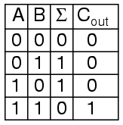

- looking at the results:

- The Σ column is an XOR gate, and,
- The Cout column is an AND gate.

- Therefore we can construct the device like so:

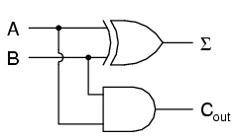

- This device is called a half-adder (for reasons that will make sense shortly).

A Full Adder

The half-adder is extremely useful until you want to add more that one binary digit quantities.

The slow way to develop a two binary digit adders would be to make a truth table and reduce it.
Then when you decide to make a three binary digit adder, do it again.
Then when you decide to make a four digit adder, do it again.
Then when ...

The circuits would be fast, but development time would be slow.

Looking at a two binary digit sum shows what we need to extend addition to multiple binary digits:

11
11
11
---
110

- Note how many inputs the middle column uses:

- The adder needs three inputs; a for one row, b for the second row, and the carry from the previous sum.

- Using our two-input adder to build a three input adder:

Σ (the total sum) is the easy part.
Normal arithmetic tells us that if Σ = a + b + Cin and Σ1 = a + b, then Σ = Σ + Cin:

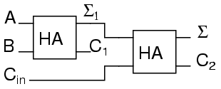
- But where do with C1 and C2 go?

- Looking at three input sums its possible to calculate:

a + b + Cin= ?
0 + 0 + 0 = 0
1 + 0 + 0 = 1
0 + 1 + 0 = 1
0 + 0 + 1 = 1
1 + 0 + 1 = 1
1 + 1 + 0 = 10
0 + 1 + 1 = 10
1 + 1 + 1 = 11

- In order to calculate the MSB bit, note that it is 1 in both cases when a + b produces a C1.
- Also, the MSB bit is 1 when a + b produces a Σ1 and Cin is a 1.

- To achieve this it requires a carry on occasions when when either C1 OR (Σ1 AND Cin) are 1 (high).

- This means to complete the adder such that we can process C1 and C2 we require an OR gate connected to the two carry outs of the half adders.

- The complete three input adder is:

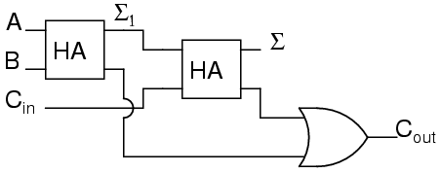

- Note, for some designs, being able to eliminate one or more types of gates can be important, and you can replace the final OR gate with an XOR gate without changing the results.

- Connecting two adders to add 2 bit quantities:

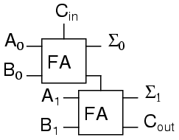

- There are several reasons for using a FA for the LSB:

- One being that we can then allow a circuit to determine whether the lowest order carry should be included in the sum.

- This allows for the chaining of even larger sums.

- Consider two different ways to look at a four bit sum.

111 1<-+ 11<+-
0110 | 01 | 10
1011 | 10 | 11
----- - | ---- | ---
10001 1 +-100 +-101

- If the program is allowed to add a two bit number and remember the carry for later, and then use that carry in the next sum, then the program can add any number of bits the user wants even though it only has a two-bit adder.

- Small PLCs can also be chained together for larger numbers.

- These full adders can also can be expanded to any number of bits space allows.

- As an example here's how to do an 8 bit adder:

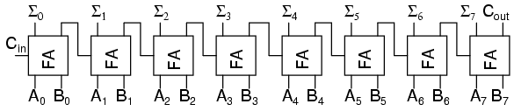
- This is the same result as using the two 2-bit adders to make a 4-bit adder and then using two 4-bit adders to make an 8-bit adder:

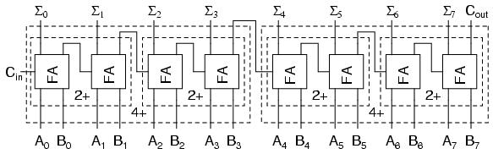

- Each "2+" is a 2-bit adder and made of two full adders.
- Each "4+" is a 4-bit adder and made of two 2-bit adders.
- And the result of two 4-bit adders is the same 8-bit adder previously built of full adders.

- For any large combinational circuit there are generally two approaches to design:
- you can take simpler circuits and replicate them; or,
- you can design the complex circuit as a complete device.

- Using simpler circuits to build complex circuits allows a you to spend less time designing but then requires more time for signals to propagate through the transistors.
- The 8-bit adder design above has to wait for all the Cxout signals to move from A0 + B0 up to the inputs of Σ7.

- If a designer builds an 8-bit adder as a complete device simplified to a sum of products, then each signal just travels through one NOT gate, one AND gate and one OR gate.
- A seventeen input device has a truth table with 131,072 entries, and reducing 131,072 entries to a sum of products will take some time.

- When designing for systems that have a maximum allowed response time to provide the final result, you can begin by using simpler circuits and then attempt to replace portions of the circuit that are too slow.
- That way you spend most of your time on the portions of a circuit that matter.

Decoders

- A decoder is a circuit that changes a code into a set of signals.
- It is called a decoder because it does the reverse of encoding, but this will study encoders and decoders beginning with decoders because they are simpler to design.
- A common type of decoder is the line decoder which takes an n-digit binary number and decodes it into 2n data lines

(dont panic at the mathematics – the truth tables and logic gate diagrams are still ok to follow).

- The simplest is the 1-to-2 line decoder.
- The truth table is:

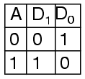
- A is the address and D is the dataline.
- D0 is NOT A and D1 is A. The circuit looks like

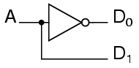

Only slightly more complex is the 2-to-4 line decoder. The truth table is

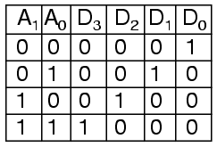

- Developed into a circuit it looks like:
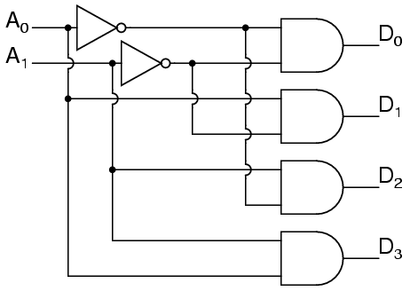

- Larger line decoders can be designed in a similar fashion;
- but, just like with the binary adder there is a way to make larger decoders by combining smaller decoders.
- An alternate circuit for the 2-to-4 line decoder is:

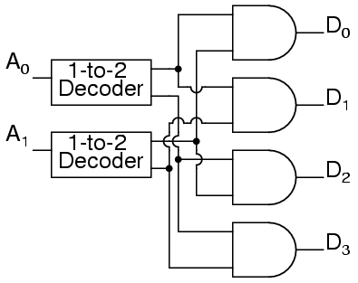

- Replacing the 1-to-2 Decoders with their circuits will show that both circuits are equivalent. - In a similar fashion a 3-to-8 line decoder can be made from a 1-to-2 line decoder and a 2-to-4 line decoder;
- And, likewise, a 4-to-16 line decoder can be made from two 2-to-4 line decoders.

- A typical application of a line decoder circuit is to select among multiple devices.
- A circuit needing to select among sixteen devices could have sixteen control lines to select which device should "listen".
- With a decoder only four control lines are needed.

Encoder

- An encoder is a circuit that changes a set of signals into a code.
- Beginning with making a 2-to-1 line encoder truth table by reversing the 1-to-2 decoder truth table:

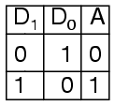

- This truth table is a little short, because a complete truth table would be:

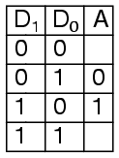

- One question to be answered is what to do with those other inputs;
- Should they be ignored or should they generate an additional error output?
- In many circuits this problem is solved by adding sequential logic in order to know not just what input is active but also which order the inputs became active.

- A specific useful application of combinational encoder design is a binary to 7-segment encoder;
- The seven segments is generally familiar as the digit on a 'digital clock' type display:

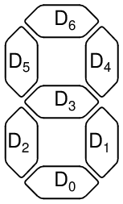

- The truth table is:

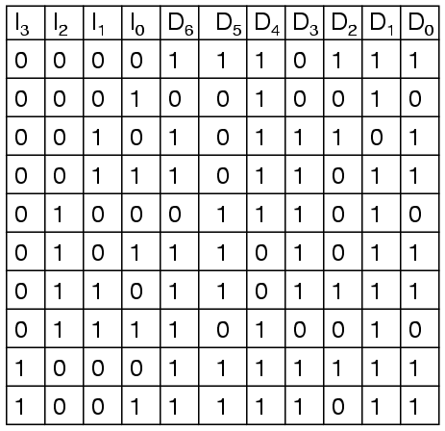

- Deciding what to do with the remaining six entries of the truth table is easier with this circuit.
- This circuit should not be expected to encode an undefined combination of inputs, so we can leave them as "don't care" when we design the circuit:

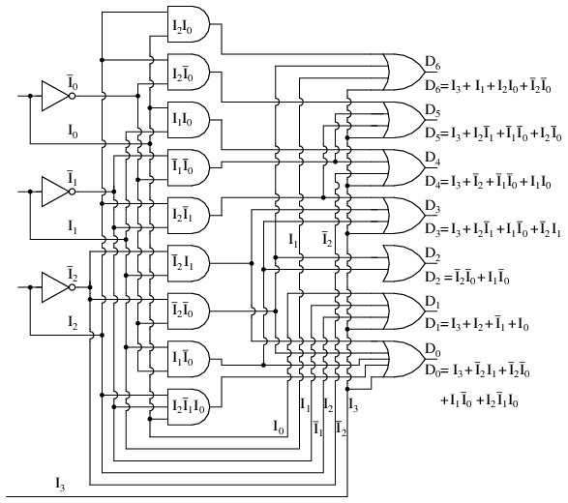

Demultiplexers

- A demultiplexer, sometimes abbreviated dmux, is a circuit that has one input and more than one output.
- It is used when a circuit wishes to send a signal to one of many devices.
- This description sounds similar to the description given for a decoder, but a decoder is used to select among many devices while a demultiplexer is used to send a signal among many devices.
- A demultiplexer is used often enough that it has its own schematic symbol

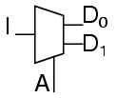

- The truth table for a 1-to-2 demultiplexer is

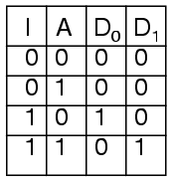

- Using the 1-to-2 decoder as part of the circuit, the circuit can be expressed as:

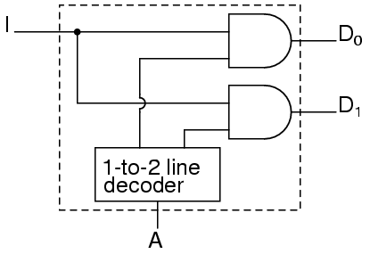

- This circuit can be expanded two different ways.
- You can increase the number of signals that get transmitted, or you can increase the number of inputs that get passed through.
- To increase the number of inputs that get passed through just requires a larger line decoder. - Increasing the number of signals that get transmitted is simpler.

- As an example, a device that passes one set of two signals among four signals is a "two-bit 1-to-2 demultiplexer".
- Its circuit is:

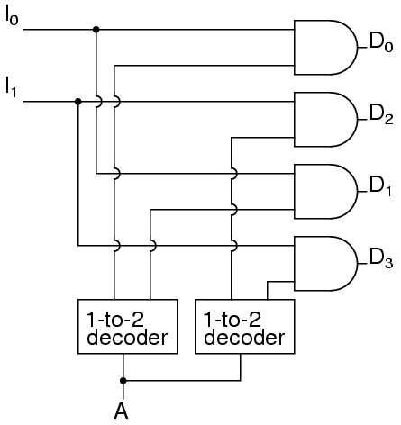

- or the circuit can be expressed as:

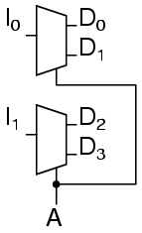

- this shows that it could be two one-bit 1-to-2 demultiplexers without changing its expected behavior.

- likewise a 1-to-4 demultiplexer can be built from 1-to-2 demultiplexers as follows:

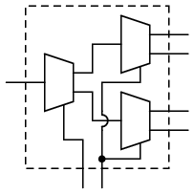

Multiplexers
- A multiplexer, abbreviated mux, is a device that has multiple inputs and one output.
- The schematic symbol for multiplexers is:

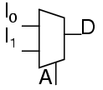

- The truth table for a 2-to-1 multiplexer is

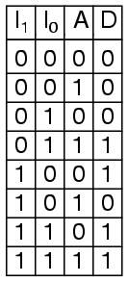

Using a 1-to-2 decoder as part of the circuit, the circuit can be expressed as:

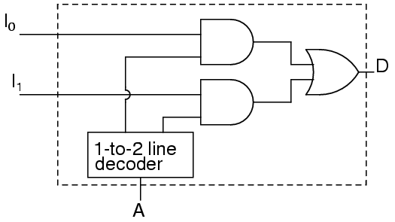

- Multiplexers can also be expanded with the same naming conventions as demultiplexers.
- A 4-to-1 multiplexer circuit is:

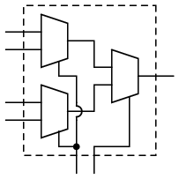

- That is the formal definition of a multiplexer.
- Informally, there is a lot of confusion.
- Both demultiplexers and multiplexers have similar names, abbreviations, schematic symbols and circuits, so confusion is easy.
- The term multiplexer, and the abbreviation mux, are often used to also mean a demultiplexer, or a multiplexer and a demultiplexer working together.
- So when you hear about a multiplexer, it may mean something quite different.

Using multiple combinational circuits

- As an example of using several circuits together, a device that will have 16 inputs, representing a four digit number, to a four digit 7-segment display can be made using just one binary-to-7-segment encoder.

- First, the overall architecture of our circuit provides looks like the description provided:

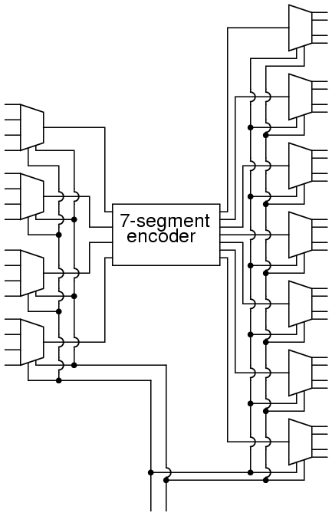

- Follow this circuit through, it can be confirmed that it matches the description given above. - There are 16 primary inputs.
- There are two more inputs used to select which digit will be displayed.
- There are 28 outputs to control the four digit 7-segment display.
- Only four of the primary inputs are encoded at a time.
- there is a potential question though:

- When one of the digits are selected, what do the other three digits display?
- Reviewing the circuit for the demultiplexers and noticing that any line not selected by the A input is zero. the other three digits are blank.
- So, there actually isn't a problem, only one digit displays at a time.

- To gain some perspective on the complexities of large circuits:

- Note how quickly this large circuit is developed from smaller parts.
- This is true of most complex circuits: they are composed of smaller parts allowing a designer to abstract away some complexity and understand the circuit as a whole.
- Sometimes a designer can even take components that others have designed and remove the detail design work.

- In addition to the added quantity of gates, this design suffers from one additional weakness. You can only see one display one digit at a time.
- If there was some way to rotate through the four digits quickly, you could have the appearance of all four digits being displayed at the same time.
- That is a job for a sequential circuit.

Sequential Logic

- There are circuits which depend on the when the inputs change, these circuits are called sequential logic.

- Sequential logic circuits make sure everything happens in order.

MULTIVIBRATORS

Digital logic with feedback

- With simple gate and combinational logic circuits, there is a definite output state for any given input state.
- Take the truth table of an OR gate, for instance:

- For each of the four possible combinations of input states (0-0, 0-1, 1-0, and 1-1), there is one, definite, unambiguous output state.
- Whether it's a multitude of cascaded gates or a single gate, that output state is determined by the truth table(s) for the gate(s) in the circuit, and nothing else.

- However, altering this gate circuit so as to give signal feedback from the output to one of the inputs, strange things begin to happen:

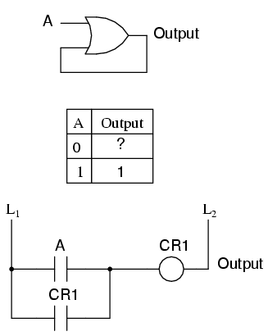

- If A is 1, the output must be 1 as well.
- Such is the nature of an OR gate: any "high" (1) input forces the output "high" (1).
- If A is "low" (0), however, the logic level or state of the output in our truth table cannot be guaranteed.

- Since the output feeds back to one of the OR gate's inputs, and knowing that any 1 input to an OR gates makes the output 1, this circuit will "latch" in the 1 output state after any time that A is 1.
- When A is 0, the output could be either 0 or 1, depending on the circuit's prior state!
- The proper way to complete the above truth table would be to insert the word latch in place of the question mark, showing that the output maintains its last state when A is 0.

- Any digital circuit employing feedback is called a multivibrator.

- The example just explored with the OR gate was a very simple example of what is called a bistable multivibrator.
- It is called "bistable" because it can hold stable in one of two possible output states, either 0 or 1.

- There are also monostable multivibrators, which have only one stable output state (that other state being momentary),
- And, astable multivibrators, which have no stable state (oscillating back and forth between an output of 0 and 1).

- A very simple astable multivibrator is an inverter with the output fed directly back to the input:

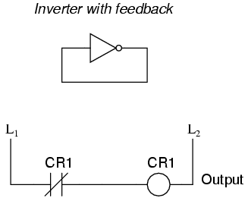

- When the input is 0, the output switches to 1.
- That 1 output gets fed back to the input as a 1.
- When the input is 1, the output switches to 0.
- That 0 output gets fed back to the input as a 0, and the cycle repeats itself.
- The result is a high frequency (several megahertz) oscillator, if implemented with a solid-state (semiconductor) inverter gate.

The S-R latch

- A bistable multivibrator has two stable states, as indicated by the prefix bi in its name.
- Typically, one state is referred to as set and the other as reset.
- The simplest bistable device, therefore, is known as a set-reset, or S-R, latch.

- To create an S-R latch, we can wire two NOR gates in such a way that the output of one feeds back to the input of another, and vice versa, like this:

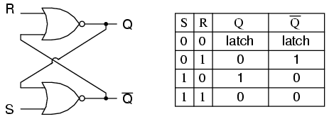

- The Q and not-Q outputs are supposed to be in opposite states.
- I say "supposed to" because making both the S and R inputs equal to 1 results in both Q and not-Q being 0.
- For this reason, having both S and R equal to 1 is called an invalid or illegal state for the S-R multivibrator.
- Otherwise, making S=1 and R=0 "sets" the multivibrator so that Q=1 and not-Q=0.
- Conversely, making R=1 and S=0 "resets" the multivibrator in the opposite state.
- When S and R are both equal to 0, the multivibrator's outputs "latch" in their prior states.

- By definition, a condition of Q=1 and not-Q=0 is set.
- A condition of Q=0 and not-Q=1 is reset.
- These terms are universal in describing the output states of any multivibrator circuit.

- The astute observer will note that the initial power-up condition of the gate S-R latch is such that both gates start in the de-energized mode.
- As such, one would expect that the circuit will start up in an invalid condition, with both Q and not-Q outputs being in the same state.
- Actually, this is true! However, the invalid condition is unstable with both S and R inputs inactive;
- as a result, the circuit will quickly stabilize in either the set or reset condition because one gate is bound to react a little faster than the other.
- If both gates were precisely identical, they would oscillate between high and low like an astable multivibrator upon power-up without ever reaching a point of stability!
- Fortunately for cases like this, such a precise match of components is a rare possibility.

- It must be noted that although an astable (continually oscillating) condition would be extremely rare,
- there will most likely be a cycle or two of oscillation in the above circuit, and the final state of the circuit (set or reset) after power-up would be unpredictable.
- The root of the problem is a race condition between the two gates CR1 and CR2.

- A race condition occurs when two mutually-exclusive events are simultaneously initiated through different circuit elements by a single cause.
- Which gate "wins" this race is dependent on the physical characteristics of the gates and not the circuit design, so the designer cannot ensure which state the circuit will fall into after power-up.

- Race conditions should be avoided in circuit design primarily for the unpredictability that will be created.
- One way to avoid such a condition is to insert a time-delay relay into the circuit to disable one of the competing relays for a short time, giving the other one a clear advantage.

It should be mentioned that race conditions are not restricted to relay circuits. Solid-state logic gate circuits may also suffer from the ill effects of race conditions if improperly designed. Complex computer programs, for that matter, may also incur race problems if improperly designed. Race problems are a possibility for any sequential system, and may not be discovered until some time after initial testing of the system. They can be very difficult problems to detect and eliminate.
In semiconductor form, S-R latches come in prepackaged units so that you don't have to build them from individual gates. They are symbolized as such:

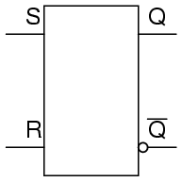

The gated S-R latch

- It is sometimes useful in logic circuits to have a multivibrator which changes state only when certain conditions are met, regardless of its S and R input states.
- The conditional input is called the enable, and is symbolized by the letter E.
- See the following example to see how this works:
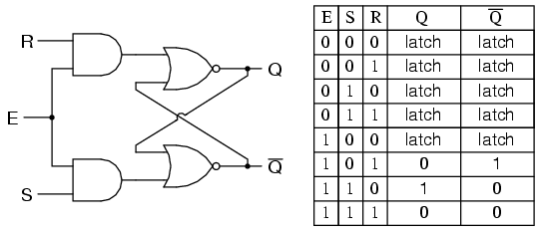

- When the E=0, the outputs of the two AND gates are forced to 0, regardless of the states of either S or R.
- Consequently, the circuit behaves as though S and R were both 0, latching the Q and not-Q outputs in their last states.
- Only when the enable input is activated (1) will the latch respond to the S and R inputs.
- Once again, these multivibrator circuits are available as prepackaged semiconductor devices, and are symbolized as such:
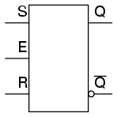

- It is also common to see the enable input designated by the letters "EN" instead of just "E."

The D latch

- Since the enable input on a gated S-R latch provides a way to latch the Q and not-Q outputs without regard to the status of S or R, we can eliminate one of those inputs to create a multivibrator latch circuit with no "illegal" input states.
- Such a circuit is called a D latch, and its internal logic looks like this:

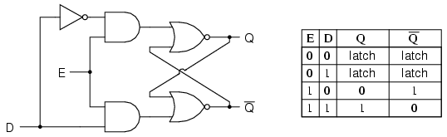

- Note that the R input has been replaced with the complement (inversion) of the old S input, and the S input has been renamed to D.
- As with the gated S-R latch, the D latch will not respond to a signal input if the enable input is 0 -- it simply stays latched in its last state.
- When the enable input is 1, however, the Q output follows the D input.

- Since the R input of the S-R circuitry has been done away with, this latch has no "invalid" or "illegal" state.
- Q and not-Q are always opposite of one another.
- If the above diagram is confusing at all, the next diagram should make the concept simpler:

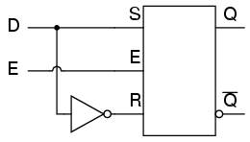

- Like both the S-R and gated S-R latches, the D latch circuit may be found as its own prepackaged circuit, complete with a standard symbol:

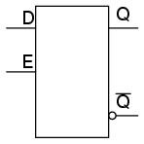
- The D latch is nothing more than a gated S-R latch with an inverter added to make R the complement (inverse) of S.
- An application for the D latch is a 1-bit memory circuit.
- You can "write" (store) a 0 or 1 bit in this latch circuit by making the enable input high (1) and setting D to whatever you want the stored bit to be.
- When the enable input is made low (0), the latch ignores the status of the D input and merrily holds the stored bit value, outputting at the stored value at Q, and its inverse on output not-Q.

Edge-triggered latches: Flip-Flops

- In many digital applications it is desirable to limit the responsiveness of a latch circuit to a very short period of time instead of the entire duration that the enabling input is activated. - One method of enabling a multivibrator circuit is called edge triggering, where the circuit's data inputs have control only during the time that the enable input is transitioning from one state to another.
- Let's compare timing diagrams for a normal D latch versus one that is edge-triggered:
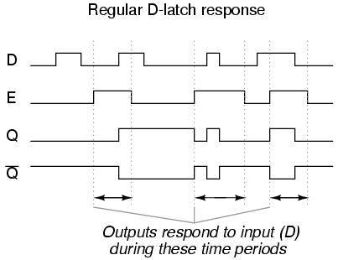

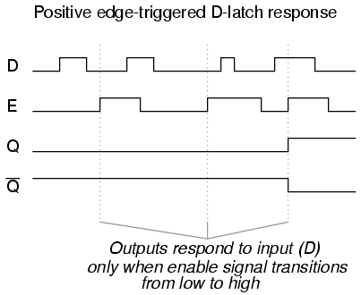

- In the first timing diagram, the outputs respond to input D whenever the enable (E) input is high, for however long it remains high.
- When the enable signal falls back to a low state, the circuit remains latched.
- In the second timing diagram, we note a distinctly different response in the circuit output(s):
- it only responds to the D input during that brief moment of time when the enable signal changes, or transitions, from low to high.
- This is known as positive edge-triggering.

- There is such a thing as negative edge triggering as well, and it produces the following response to the same input signals:

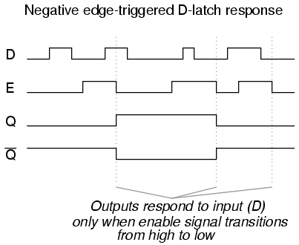

- Whenever a multivibrator circuit is enabled on the transitional edge of a square-wave enable signal, it is called a flip-flop instead of a latch.
- Consequently, and edge-triggered S-R circuit is more properly known as an S-R flip-flop, and an edge-triggered D circuit as a D flip-flop.
- The enable signal is renamed to be the clock signal.
- Also, the data inputs (S, R, and D, respectively) of these flip-flops are referred to as synchronous input
- (because they have effect only at the time of the clock pulse edge (transition), thereby synchronizing any output changes with that clock pulse, rather than at the whim of the data inputs.)

- But, how is this edge-triggering actually accomplished?
- To create a "gated" S-R latch from a regular S-R latch is easy enough with a couple of AND gates, but, to implement logic that only pays attention to the rising or falling edge of a changing digital signal needs something more:
- What is needed is a digital circuit that outputs a brief pulse whenever the input is activated for an arbitrary period of time
- the output of this circuitcan be used to briefly enable the latch.
- this is technically a kind of monostable multivibrator, which for now we'll call a pulse detector:

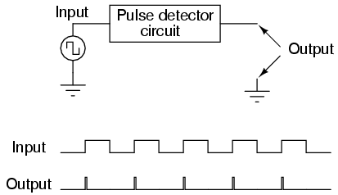

- The duration of each output pulse is set by components in the pulse circuit itself. This can be accomplished quite easily through the use of a time-delay relay with a very short delay time:

- Implementing this timing function with semiconductor components is actually quite easy, as it exploits the inherent time delay within every logic gate (known as propagation delay).
- An input signal is split up two ways, then a gate or a series of gates placed in one of those signal paths just to delay it a bit.
- Then both the original signal and its delayed counterpart enter into a two-input gate that outputs a high signal for the brief moment of time that the delayed signal has not yet caught up to the low-to-high change in the non-delayed signal.
- An example circuit for producing a clock pulse on a low-to-high input signal transition is shown here:

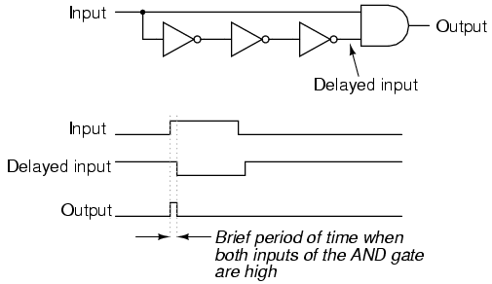

- This circuit may be converted into a negative-edge pulse detector circuit with only a change of the final gate from AND to NOR:
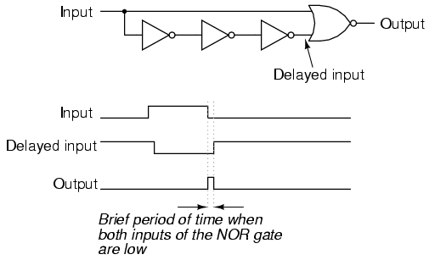

- Now that we know how a pulse detector can be made, we can show it attached to the enable input of a latch to turn it into a flip-flop.
- In this case, the circuit is a S-R flip-flop:

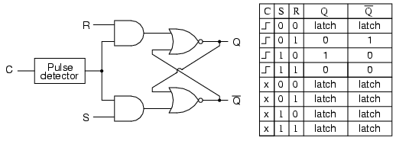
– Only when the clock signal (C) is transitioning from low to high is the circuit responsive to the S and R inputs.
- For any other condition of the clock signal ("x") the circuit will be latched.

- It is important to note that the invalid state for the S-R flip-flop is maintained only for the short period of time that the pulse detector circuit allows the latch to be enabled.
- After that brief time period has elapsed, the outputs will latch into either the set or the reset state.

- Once again, the problem of a race condition manifests itself.
- With no enable signal, an invalid output state cannot be maintained.
- However, the valid "latched" states of the multivibrator -- set and reset -- are mutually exclusive to one another;
- Therefore, the two gates of the multivibrator circuit will "race" each other for supremacy, and whichever one attains a high output state first will "win."

- The block symbols for flip-flops are slightly different from that of their respective latch counterparts:

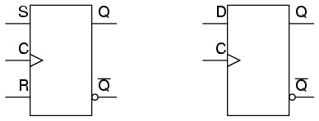
- The triangle symbol next to the clock inputs tells us that these are edge-triggered devices, and consequently that these are flip-flops rather than latches.
- The symbols above are positive edge-triggered: that is, they "clock" on the rising edge (low-to-high transition) of the clock signal.
- Negative edge-triggered devices are symbolized with a bubble on the clock input line:

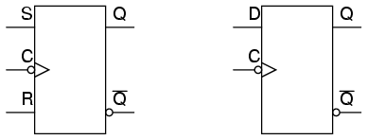

- Both of the above flip-flops will "clock" on the falling edge (high-to-low transition) of the clock signal.

- Another variation on a theme of bistable multivibrators is the J-K flip-flop.
- Essentially, this is a modified version of an S-R flip-flop with no "invalid" or "illegal" output state.
- Look closely at the following diagram to see how this is accomplished:

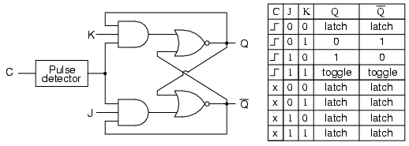

- What used to be the S and R inputs are now called the J and K inputs, respectively.
- The old two-input AND gates have been replaced with 3-input AND gates, and the third input of each gate receives feedback from the Q and not-Q outputs.
- What this does for us is permit the J input to have effect only when the circuit is reset, and permit the K input to have effect only when the circuit is set.
- In other words, the two inputs are interlocked, to use a relay logic term, so that they cannot both be activated simultaneously.
- If the circuit is "set," the J input is inhibited by the 0 status of not-Q through the lower AND gate; if the circuit is "reset," the K input is inhibited by the 0 status of Q through the upper AND gate.

- When both J and K inputs are 1, however, something unique happens.
- Because of the selective inhibiting action of those 3-input AND gates, a "set" state inhibits input J so that the flip-flop acts as if J=0 while K=1 when in fact both are 1.
- On the next clock pulse, the outputs will switch ("toggle") from set (Q=1 and not-Q=0) to reset (Q=0 and not-Q=1).
- Conversely, a "reset" state inhibits input K so that the flip-flop acts as if J=1 and K=0 when in fact both are 1.
- The next clock pulse toggles the circuit again from reset to set.

- The end result is that the S-R flip-flop's "invalid" state is eliminated (along with the race condition it engendered) giving a useful feature as a bonus: the ability to toggle between the two (bistable) output states with every transition of the clock input signal.
- There is no such thing as a J-K latch, only J-K flip-flops.
- Without the edge-triggering of the clock input, the circuit would continuously toggle between its two output states when both J and K were held high (1), making it an astable device instead of a bistable device in that circumstance.
- If we want to preserve bistable operation for all combinations of input states, we must use edge-triggering so that it toggles only when we tell it to, one step (clock pulse) at a time.

- The block symbol for a J-K flip-flop is a whole lot less frightening than its internal circuitry, and just like the S-R and D flip-flops, J-K flip-flops come in two clock varieties (negative and positive edge-triggered):

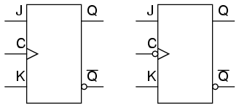

Asynchronous flip-flop inputs

- The normal data inputs to a flip flop (D, S and R, or J and K) are referred to as synchronous inputs because they have effect on the outputs (Q and not-Q) only in step, or in sync, with the clock signal transitions.
- These extra inputs are called synchronous because they can set or reset the flip-flop regardless of the status of the clock signal.
- Typically, they're called preset and clear:

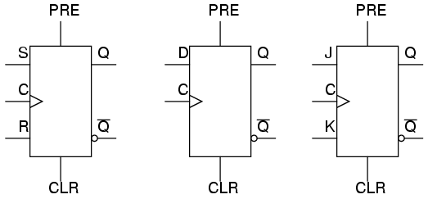

- When the preset input is activated, the flip-flop will be set (Q=1, not-Q=0) regardless of any of the synchronous inputs or the clock.
- When the clear input is activated, the flip-flop will be reset (Q=0, not-Q=1), regardless of any of the synchronous inputs or the clock.
- So, what happens if both preset and clear inputs are activated? Surprise, surprise: we get an invalid state on the output, where Q and not-Q go to the same state, the same as our old friend, the S-R latch!
- Preset and clear inputs find use when multiple flip-flops are ganged together to perform a function on a multi-bit binary word, and a single line is needed to set or reset them all at once.

- Asynchronous inputs, just like synchronous inputs, can be engineered to be active-high or active-low.
- If they're active-low, there will be an inverting bubble at that input lead on the block symbol, just like the negative edge-trigger clock inputs.

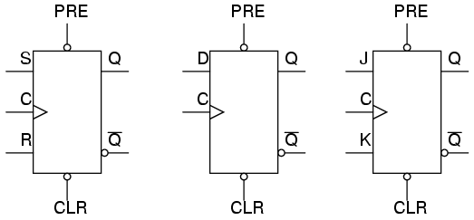

- Sometimes the designations "PRE" and "CLR" will be shown with inversion bars above them, to further denote the negative logic of these inputs:

